Address | Type | 2000 | 2010 | 2020 | 2030 | 2040 | 2050 | 2060 | 2070 | 2080 | B year | D year | Lifespan
1 Sweet Street | SF
2 Sweet Street | SF
3 Sweet Street | SF
4 Sweet Street | SF
5 Sweet Street | SF
6 Sweet Street | SF
1-3 Sugar Ave | MF
5-7 Sugar Ave | MF
2-4 Sugar Ave | MF
6-8 Sugar Ave | MF
Built (B) | SF
Demolish (D) | SF
Stock (S) calc. | SF
Stock (S) count | SF
Built (B) | MF
Demolish (D) | MF
Stock (S) calc. | MF
Stock (S) count | MF
Stock (S) sum | Total

❸ Home Tracker: Construction Manager (CM) and Debris and Demolition Manager (DDM)
Instructions:
- Put a “B” when it is built, “S” when in stock, and “D” when it is demolished. Write the B year and D year and calculate the Lifespan = D year – B year.
- At the bottom, put the count of SF and MF homes Built (B), Demolished (D) that year.
- For Stock (S) calc: Calculate the ${Stock}_{t}={Stock}_{t-1}+{\sum{{FlowIn}_{t}}-\sum{{FlowOut}_{t}}}_{}$ . Note that ${Stock}_{1999}=0$.
- For Stock (S) count: put the count of SF and MF homes that are new or already existing Stock (S) that year. Compare your count to the calculation.

❶Flow Tracker: Materials Warehouse Manager (MWM)
Instructions:
- Flow In₂₀₀₀ = initial new materials
- Flow In_{>2000} = purchase of recycled materials from WRM
- Flow Out = sales of materials to CRM
- ${Stock}_{t}={Stock}_{t-1}+{\sum{{FlowIn}_{t}}-\sum{{FlowOut}_{t}}}_{}$
  - rearrange the above formula to calculate stock change based on Flow In and Flow Out
- Stock Δ = stock change = ${Stock}_{t}-{Stock}_{t-1}$
- ${Stock}_{1999}=0$
 | Brick |  |  |  | Wood |  |  |  | Metal |  |  |  | Glass
Year | Flow In | Flow Out | Stock Δ | Stock | Flow In | Flow Out | Stock Δ | Stock | Flow In | Flow Out | Stock Δ | Stock | Flow In | Flow Out | Stock Δ | Stock
2000
2010
2020
2030
2040
2050
2060
2070
2080
Total

❻Flow Tracker: Waste & Recycling Manager (WRM)
Instructions:
- Flow In = scrap and debris from DDM
- Flow Out = sales of reusable or recycled materials to MWM
- ${Stock}_{t}={Stock}_{t-1}+{\sum{{FlowIn}_{t}}-\sum{{FlowOut}_{t}}}_{}$
  - rearrange the above formula to calculate stock change based on Flow In and Flow Out
- Stock Δ = stock change = ${Stock}_{t}-{Stock}_{t-1}$
- ${Stock}_{1999}=0$
 | Brick for Reuse |  |  |  | Wood for Reuse |  |  |  | Metal for Recycling |  |  |  | Combined Scrap &  Debris for Landfill
Year | Flow In | Flow Out | Stock Δ | Stock | Flow In | Flow Out | Stock Δ | Stock | Flow In | Flow Out | Stock Δ | Stock | Flow In | Flow Out | Stock Δ | Stock
2000
2010
2020
2030
2040
2050
2060
2070
2080
Total

❹Flow Tracker: Construction Manager (CM) and Debris and Demolition Manager (DDM)
Instructions:
- Flow In = construction materials from MWM
- Flow Out = scrap and debris to WRM
- ${Stock}_{t}={Stock}_{t-1}+{\sum{{FlowIn}_{t}}-\sum{{FlowOut}_{t}}}_{}$
  - rearrange the above formula to calculate stock change based on Flow In and Flow Out
- Stock Δ = stock change = ${Stock}_{t}-{Stock}_{t-1}$
- ${Stock}_{1999}=0$
- For the 50th Anniversary Golden Jubilee, put the count in the specified row for comparison.
 | Brick |  |  |  | Wood |  |  |  | Metal |  |  |  | Glass
Year | Flow In | Flow Out | Stock Δ | Stock | Flow In | Flow Out | Stock Δ | Stock | Flow In | Flow Out | Stock Δ | Stock | Flow In | Flow Out | Stock Δ | Stock
2000
2010
2020
2030
2040
2050
2050 | Golden Jubilee Count: |  |  |  | Golden Jubilee Count: |  |  |  | Golden Jubilee Count: |  |  |  | Golden Jubilee Count:
2060
2070
2080
Total

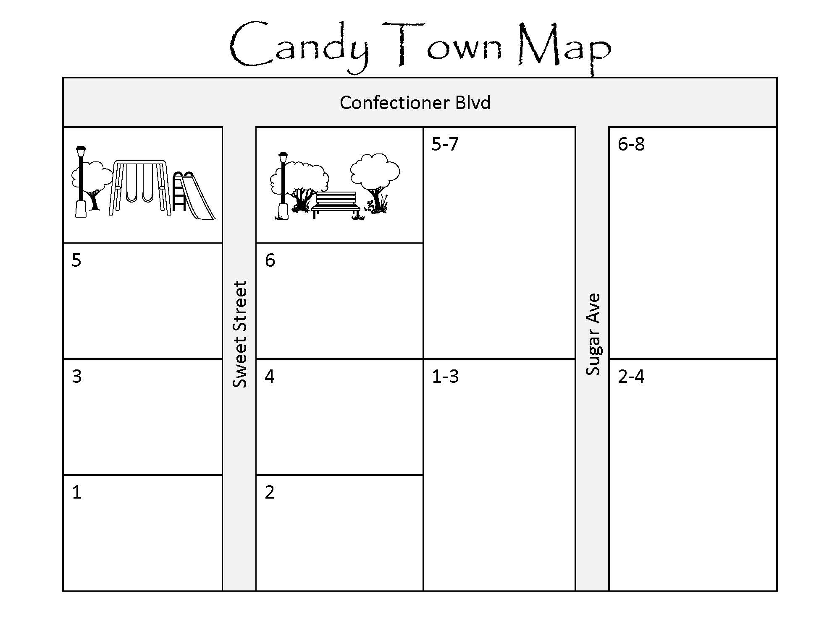

❺Lifespan Distribution
Industrial Ecology researchers who recently settled in Hummus Town realized that the buildings in Candy Town could make an excellent case study. They modeled the lifespan distribution of the buildings using a Weibull Distribution, which is a commonly used approach for lifespans, since it was developed with that sort of purpose in mind. Instead of mean and standard deviation, the parameters for a Weibull Distribution are shape, scale, (and optionally shift).
Each point in the chart below represents the likelihood a house would be demolished after that many years.

Let’s compare this to the data you collected. Since data was only available in Candy Town every decade, the researchers took the difference between cumulative Weibull distribution above over the preceding range. For instance, the 10.5% is the difference between the cumulative distribution at year 20 and year 10; 25.4% is the value at year 30 minus year 20.

Based on your results in the Home Tracker ❸, fill out the table below, and plot your percentages above!
- Count how many buildings have each lifespan (years).
- Find the percent of buildings with that lifespan, noting there are 10 buildings total.
- Plot your results and compare to the model estimates, plotted above and in the bottom row of the table.
Lifespan | 0 | 10 | 20 | 30 | 40 | 50 | 60 | 70 | 80
Count
Percent
Model | 0.0% | 0.0% | 10.5% | 25.4% | 27.3% | 19.9% | 10.7% | 4.4% | 1.4%

❷Materials Warehouse Manager (MWM) Material Storage
Brick | Wood
Metal | Glass

❼Waste & Recycling Manager (WRM) Material Storage
Brick for Reuse | Wood for Reuse
Metal for Recycling | Combined Scrap & Debris for Landfill

